SLICED PEARS IN LIGHT SYRUP in 6/10 can, Product of China

NEMCO UPC Barcode: 767301401362

**Product Description:**

Pear slices in light syrup

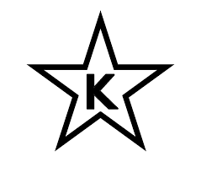

NEMCO products are certified as Kosher when bearing the symbol on the label.

**Nutrition Information:**

**Ingredients:**

Pears, water, sugar, citric acid

**Physical Analysis:**

Color: Characteristic of properly prepared and processed mature fruit

Taste/Odor: Typical, no off taste or odor

Texture: Uniform ripeness and texture

pH: 3.7 – 4.2

Microbiological Standards: Commercially sterile

**Storage:**

Keep in a dry and cool place. Ambient, suggested temperature between 40 °F - 80 °F. Protect from direct sun light.

Shelf Life 3 years.

**Product Handling:**

After opening, transfer the content and juice to a non-metallic container with the maximum of liquid as possible, keep refrigerated and finish before 5 days.

**Packaging:**

Case Size: 6/10

Net Weight: 3,005 g (106 oz)

Drained Weight: 1,743g (61.48 oz)

Case Dimensions: 18.7” x 12.4” x 7.0”

Case Cube: 0.94 CFT

Cases/Pallet: 56 CS/P